**Trabalho – Arduino**

**Laboratório de Circuitos Digitais**

**Aluno: Raul Alexandre Gonzalez Augusto**

**RA: 211023698**

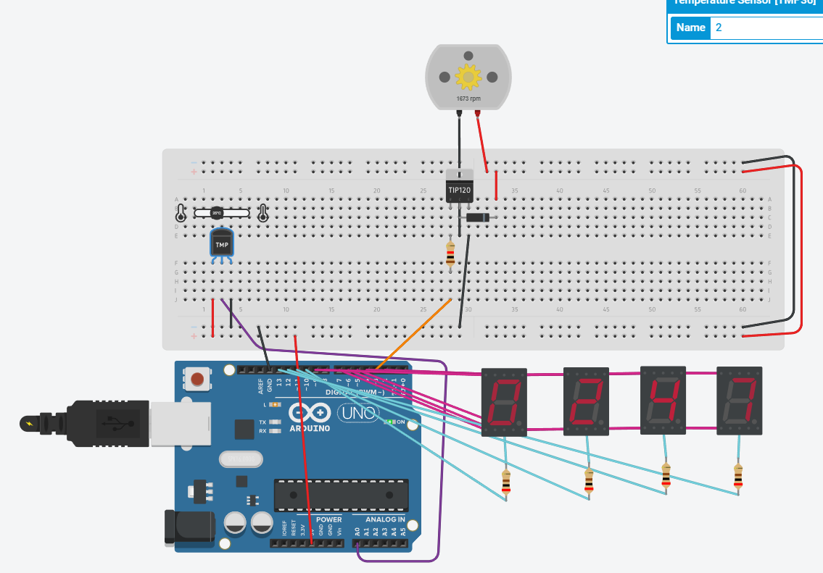

<https://www.tinkercad.com/things/cxp9roqzski-magnificent-blad/editel?sharecode=OAUsZlavnLOEuXEVHF7xjBy_ZGe4hZGhfaWQ2mrq1sA>